# INFSCI 2725 Data Analytics

# Assignment 9 – Data Visualization

# Student name: Ying Ma, Weiyi Tuo, Kaiyang Lyu

## Introduction

Data is very powerful, but it’s not easy to pick up information from numerous data directly. Data visualization is an effective way to presence data in the format of pictorial and graphical, which can help auditors understand the trend and status much more easily. In the report, we find three examples online and to give our evaluation.

## Example 1

Figure 1 is a data visualization of top 10 military spenders in the world by total amount in 2013. In this picture, it makes a typical mistake of chart junk. Although use bullet to replace regular bar is make the chart more imaginable, the data visualization cannot represent the real data accuracy. We may see that the military spending of China is more than half which of America, but actually the number is $188 vs $ 640, only about 30%. It is possible that the data is represented by the volume of bullet, but it’s not intuitionistic. Another drawback is the shadow of each bullet may confused audiences and disturb their attention. So the easiest way to improve this chart is to substitute normal bar for bullet, the height of bar represents the money spending, and to remove the shadows.

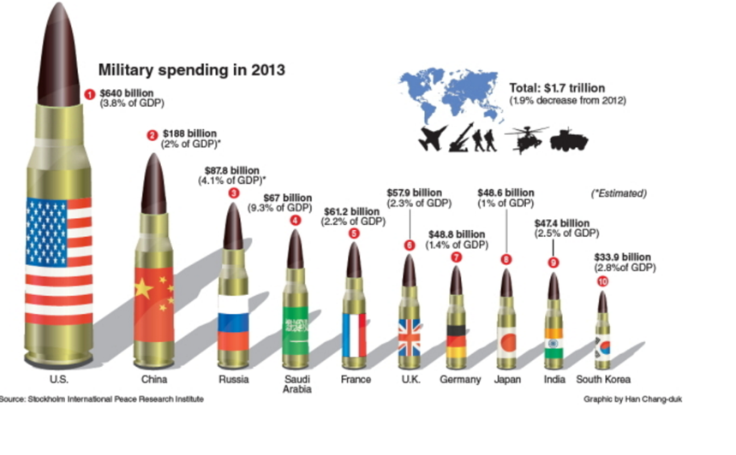

（Figure1. <http://junkcharts.typepad.com/.a/6a00d8341e992c53ef01b8d085c17e970c-pi>）

## Example 2

The figure2 is a 3-D chart which shows the data of three items from Jan to Dec in 2010. Here are some problems. First, the data-ink ratio is quite low because of the colorful background and band line. Second, in 3-D space, it is hard to read the value of y-axis, and compare the value. Actually in this picture, there is no need to use 3-D chart to present the data. So we can re-draw the chart in 2-D space. the other thing we can do is to eliminate the colorful background and just use three different single colors to present the items.

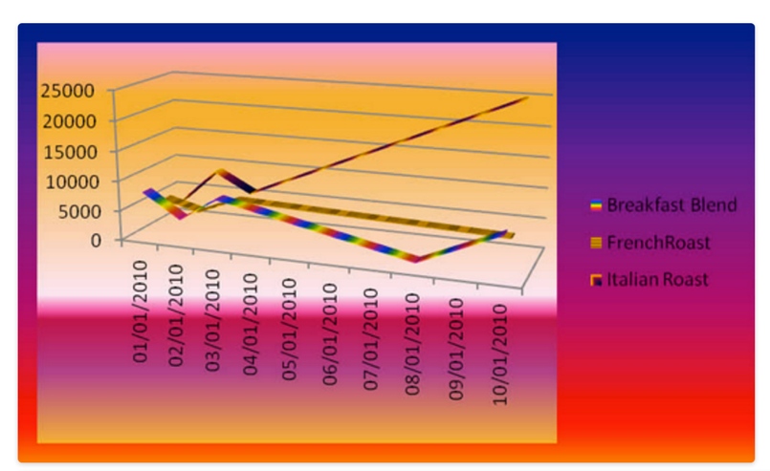

(Figure 2. <http://civicmedia.info/ideas/workshop-communicating-data-effectively-with-visualizations/)>

## Example 3

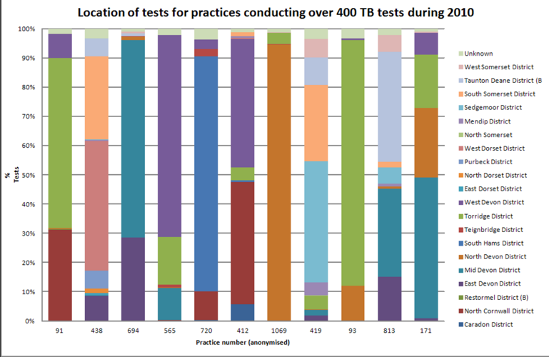

(Figure 3. <http://biosecurityresearch.blogspot.com/2011_10_01_archive.html)>

This example of data visualization also has some drawbacks. The biggest problem is the chart junk: it may be difficult to pick out some of the colors for the different. For those tiny occupancy district, it is easy to be neglected. Another thing is from this chart, it’s also hard to read and compare the percentage of the location. There are also some ways to improve the chart. We may dismiss some useless practice number, just focus on few of them, and draw them as a pan chart one by one. If it required that all the information should be in the same chart, we may use the same color order for all the bars and make the boundaries more obviously.